IOStreams or File Handling
_____________________________________________________________________________________
IOStreams stands for input and output streams called as IOStreams
Streams means to transfer the data from one location to another location or from one machine to another machine called as streams
Means if we think about programming if we transfer the data from one memory to another memory like as from RAM to hard disk or hard disk to RAM or we share in network from one computer to another computer called as IOStreams.
If we want to work with IOStreams in Java we have package name as java.io package and in this package contain some classes and interfaces which help us to work with files or input and output devices.
If we want to work with IOStreams we should have to know the location where we want to send data or read data and for that we required, the destination path from data want to read or where data want to write etc
If we want to work with Path in file handling, we have to use File class

Q. What is File class?
File class is used for access the path from System as well as access the all drives detail like as total number of drive, its name, total size of drive, free size of drive, creating folder, creating file, deleting folder, deleting file, access all files and folder from system etc

How to access all drive from System using File class?
_____________________________________________________________________________________
If we want to access the all drives from System using File class we have method name as listRoots() and this is the static method of File class and this method return array of File class which contain all drive details like as drive name, total space, free space etc
Syntax: File ref [] = File.listRoots()
Methods related with drive details?
long getTotalSpace(): this method can return total space of drive in bits format.
long getFreeSpace(): this method can return free space of drive.
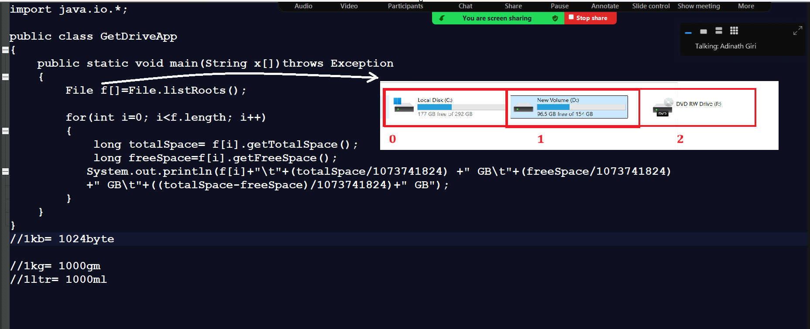

boolean mkdir() : this method is used for create folder using File class and If folder created successfully return true otherwise return false.

boolean exists() : this method check whether path i.e file or folder exists on specified path if file or folder already present return true otherwise return false.
Example: we want to create folder javademo in feb2024 on D drive
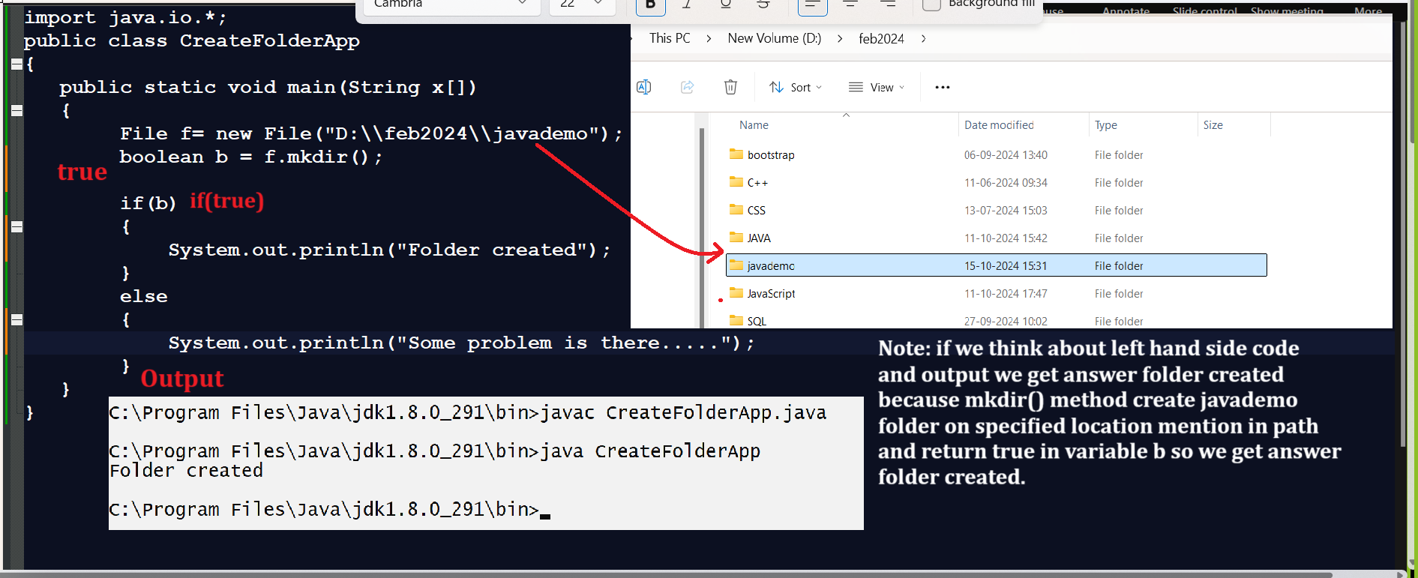

Note: if we execute same code repeat again then your output like as
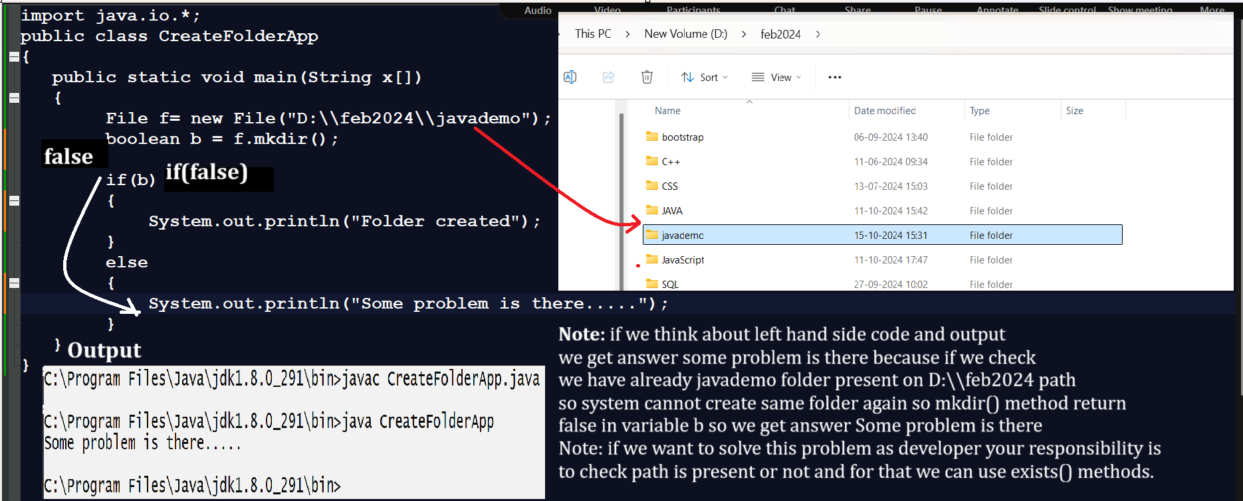

Following code demonstrate use of exists() method for check path on drive
_________________________________________________________________________
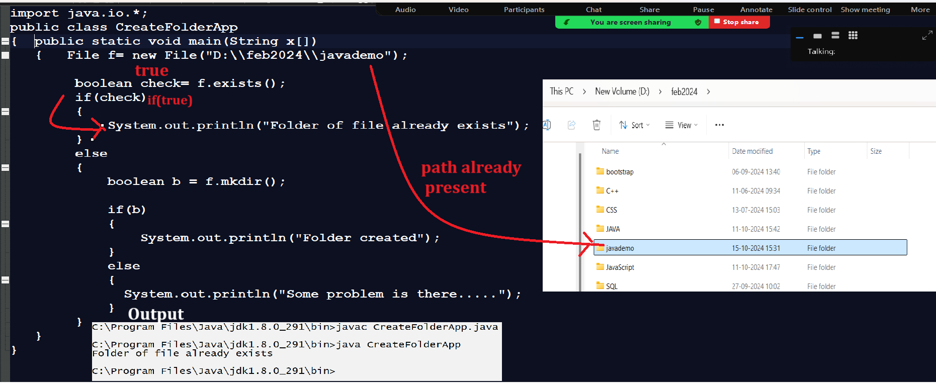

How to get all folders and files from particular path
_____________________________________________________________________________________
If we want to get all folders and file from particular path then we have method of File class name as
listFiles() and this method return File class array.
Syntax: File ref []= File.listFiles();
Example: we want to fetch all files and folder from D:\\feb2024 path
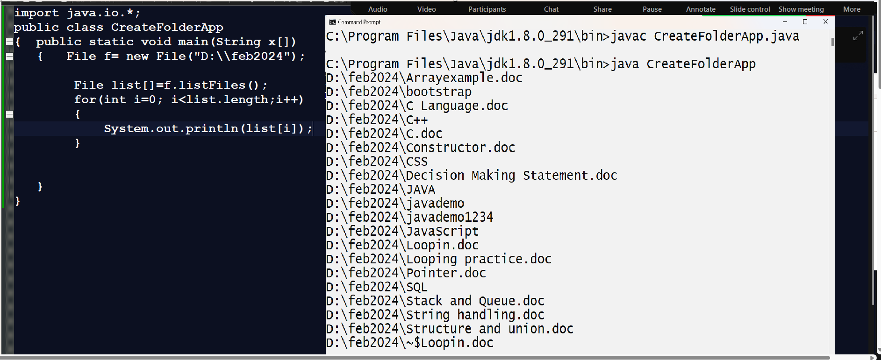

Note: if we want to check return path is file or folder means if we think about above output, we get mixed files and folder but if we want to fetch only folder then we required to check path is folder or not and for that we have method name as

boolean isDirectory(): this function check return path is folder and if path is folder return true otherwise return false.

boolean isFile(): this function check return path is file or not if path contain file return true otherwise false.

Following code show fetch only folders

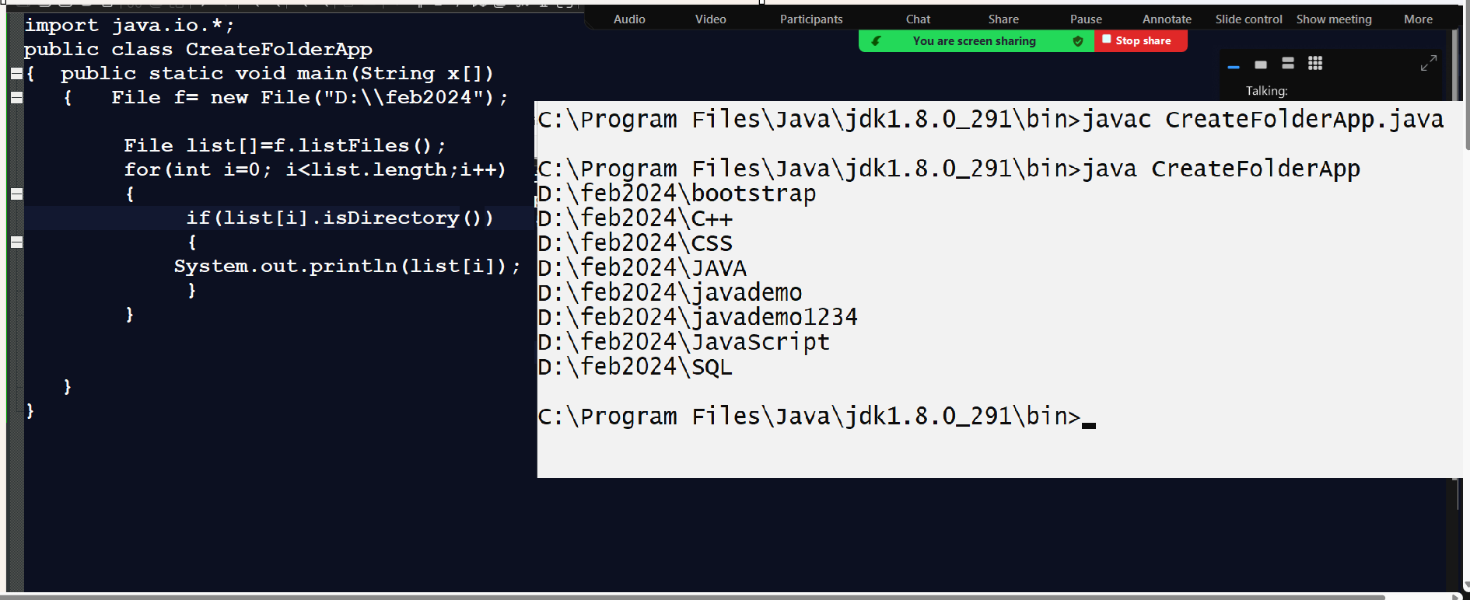

Example: Fetch only files from particular path.
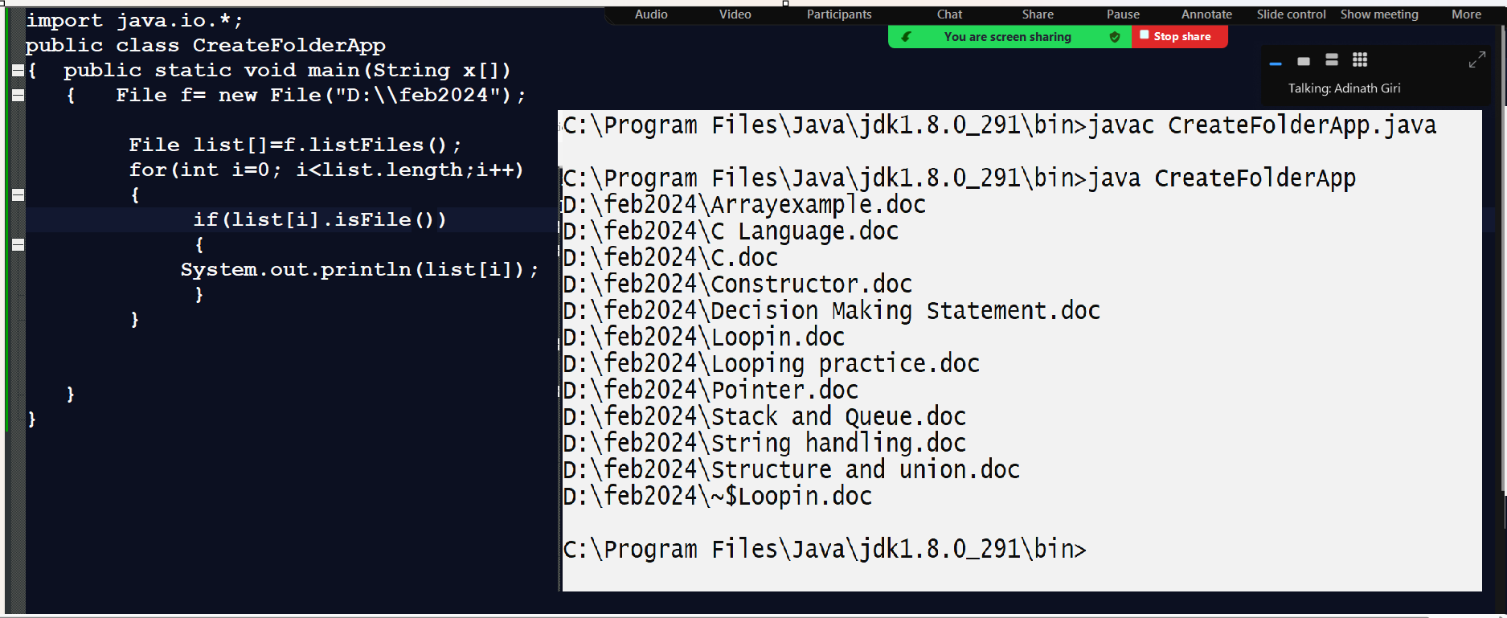

How to create file using File class
_____________________________________________________________________________________
If we want to create file using File class, we have method

boolean createNewFile(): this method create new file and if file created successfully return true otherwise return false.

Example with source code
import java.io.*;
public class CreateFolderApp
{ public static void main(String x[])throws IOException
{ File f= new File("D:\\feb2024\\employee.doc");
boolean b=f.createNewFile();
if(b)
{ System.out.println("File created successfully............");
}
else
{ System.out.println("Some problem is there..............");
}
}
}

Note: once we create file then we can write data in file or read data from file.
If we want to write data in file or read data from file we have two ways.

1. Write or Read data using text format: Suppose consider if we want to work with document format like as notepad file, word pad etc then we can use text format.

2. Write or Read data using byte format: if we want to work with image, audio, video etc then we can use the byte format.

So work with text format or byte format using Java we have some types of class or we have some inbuilt classes provided by java to us

Write or Reader: those classes end with write or reader word then they can work for text format
Stream: Those classes end with Stream word then they can work for byte format.

Now we want to discuss about the Writer class
_____________________________________________________________________________________
Writer is a class from java.io package which is used for write data in file using a text format and it is abstract class present in java.io package and which contain some abstract methods which help us to write data in file.

Following class hierarchy demonstrate Writer classes
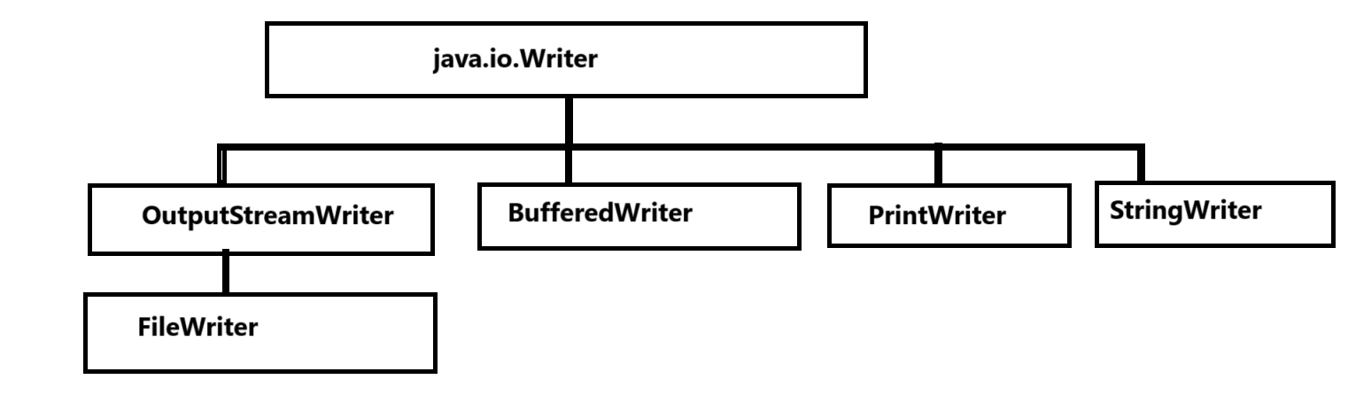

If we think about java.io.Writer class it is abstract and it contain following methods for write data in file
_____________________________________________________________________________________
void write(char): this method can accept single character data and write in file.

void write(String): this method can accept string data and write in file.

void write(String ,int offset,int length): this method can write specified length of data in file using its index and length

Parameter details: -
String data: this parameter indicate we have original data or actual data present which we want to write

int offset: this parameter indicates the index from data want to write

int length: this parameter indicates actual data want to write in file.

void write(char [],int offset,int length): this method is used for write specified length of data from character array in file

Parameter details: -
char []: this parameter indicate we have original data or actual data present which we want to write
int offset: this parameter indicates the index from data want to write
int length: this parameter indicates actual data want to write in file.

void close(): this method can close the file data
void flush(): this method can flush the data from buffer memory
etc

Now we want to discuss about the FileWriter class
_____________________________________________________________________________________
Constructor of FileWriter class

a) FileWriter(String path): this constructor can accept the file using a string format and by default use the write mode.
If we think about file writing approach, we have two types of mode in file handling

Write mode: Write mode means if file is not exist then create new file and file is exist then override the previous content of file using new content.

Append mode: Append mode means if file is not exist then create new file and if file is exist then persist previous data of file and new data at end of file.

b) FileWriter(String path ,boolean mode):

String path: this parameter indicate accept file path using a string format.

boolean mode: this parameter indicate file can work with append mode or not if we pass true parameter in it then file can use append mode if we pass false parameter then file can use write mode.

c) FileWriter(File path): this constructor accept file path using file class reference and work with write mode.

d) FileWriter(File path, boolean mode):

File path: this parameter indicate accept file path using a file class reference

boolean mode: this parameter indicate file can work with append mode or not if we pass true parameter in it then file can use append mode if we pass false parameter then file can use write mode.

Note: FileWriter is a child of Writer class so we can access all methods of Writer using FileWriter object.

Example: we want to create text file and store data in it.

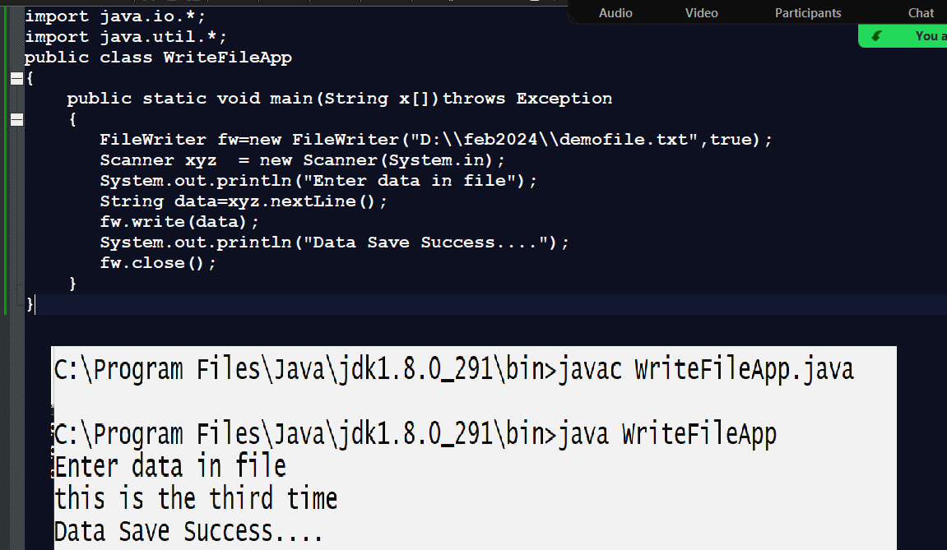

Note: The limitation of FileWriter is we cannot write data on new line in file just we can write data in same line so if we want to write data in file on new line we have one more class name as BufferedWriter class

BufferedWriter class
________________________________________________________________________
BufferedWriter class is used for write data in new file on new line and BufferedWriter contain method name as newLine() which help us to add new line in file.

Constructor of BufferedWriter class
________________________________________________________________________________
BufferedWriter(Writer): this constructor contain Writer class reference and Writer is parent of all writer classes so here we can pass any child class reference of Writer class.

Example: We want to create file using BufferedWriter class and write data in file
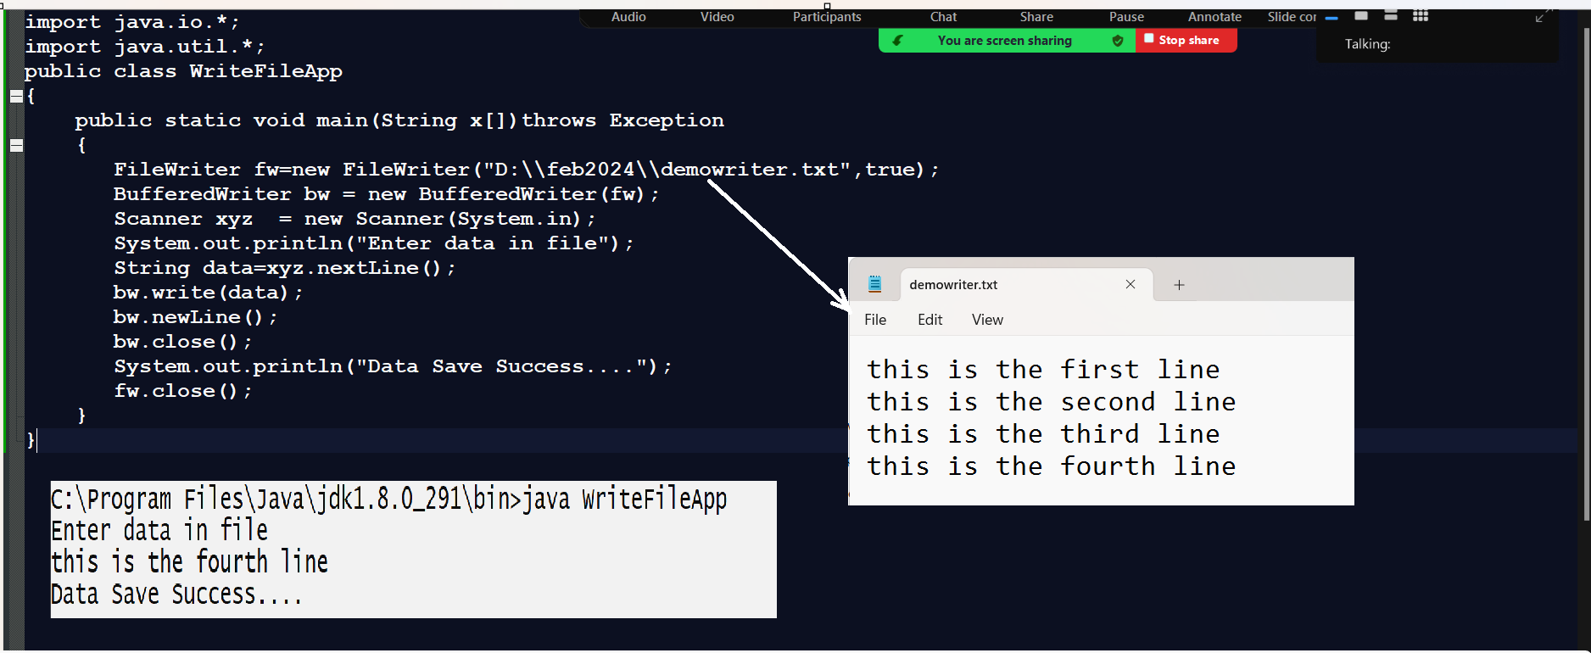

Reader classes: Reader classes help us to read data from file using a text format if we want to work with Reader classes we have following class hierarchy.
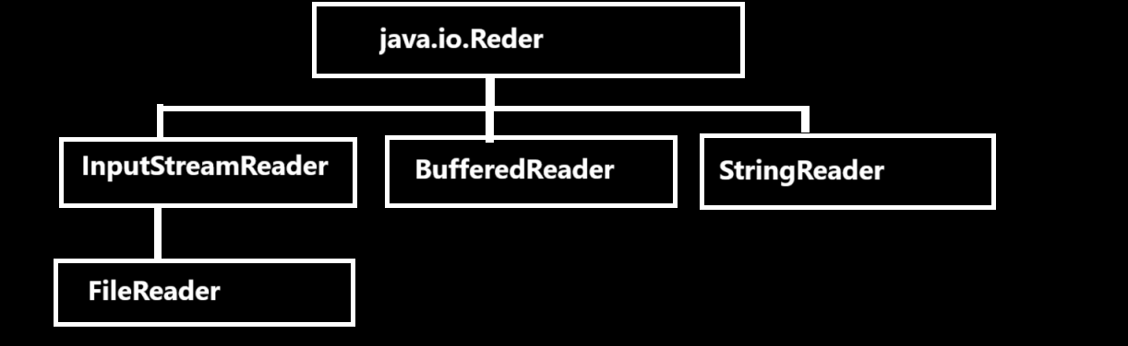
If we think about above diagram we have top most class name as Reader class and it is abstract class and it contain some abstract methods which help us to read data from file using text format

Methods of Reader class
_________________________________________________________________________________
int read(): this function can read single character from file and return its ascii code and if file does not have data or file end then return -1

int read(char[]): this function can read complete file data and store in character array and return its length and if not contain data then return -1.

int read(char[],int offset,int length): this method can read specified data from file and return its length

char []: this parameter indicate we have original data or actual data present which we want to read

int offset: this parameter indicate the index from data want to read

int length: this parameter indicate actual data want to read from file.

void close(): this method can close the file data.

FileReader class: this class contain read data using character format and use the by default read mode.

Constructor of FileReader class
FileReader(String path): this constructor can accept the file path using string format

FileReader(File path): this constructor can accept the file path using file class reference.
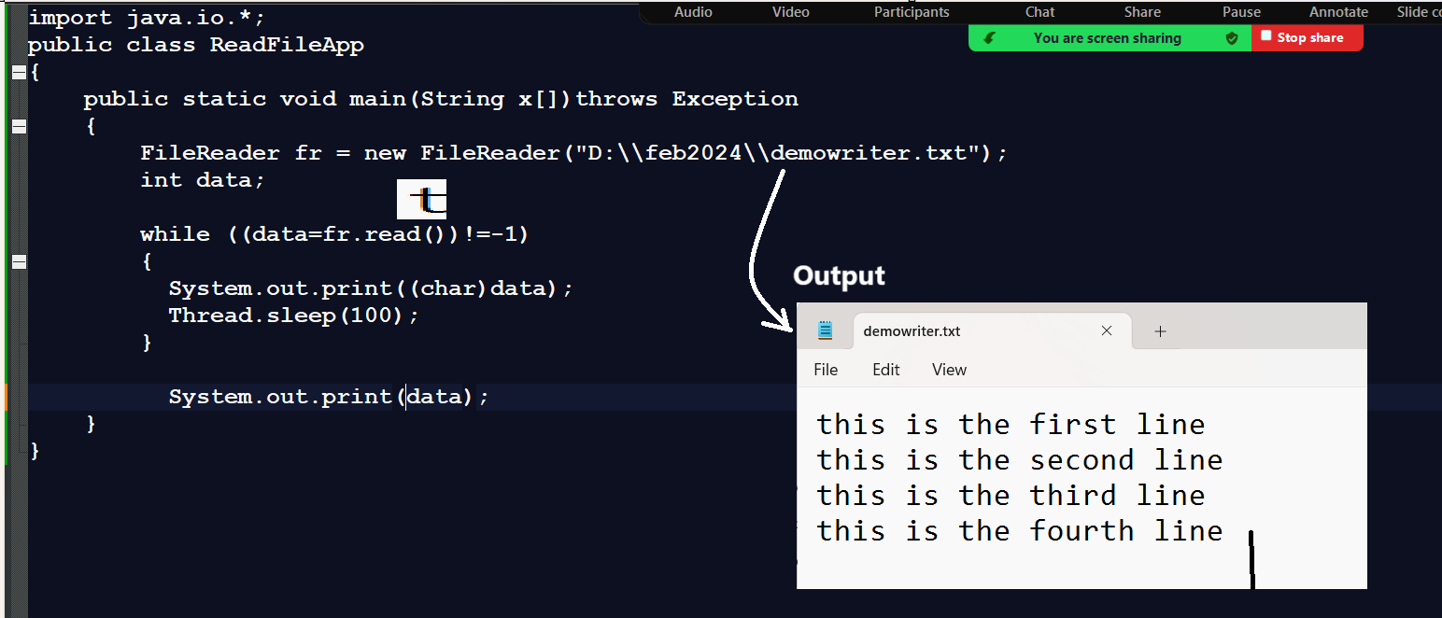
Note: if we think about FileReader class so this class read file data using single character at time so if we read complete line or statement from file at time, we have new class name as BufferedReader class.
BufferedReader class contain readLine() method which is used for read complete line at time from file.

Syntax:
BufferedReader(Reader): this constructor can accept Reader as parameter means we can pass here reference of any child of Reader class

Method for read complete line at time

String readLine(): this method can read complete line of data from file otherwise return null value.
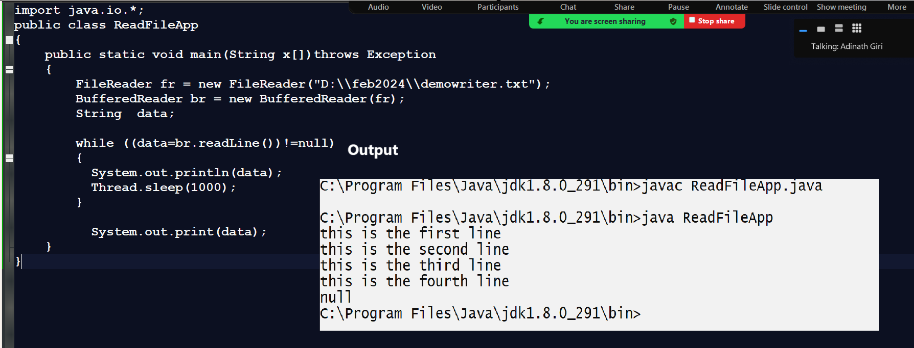

Stream classes: Stream classes help us to write byte format data in file or read byte format data from file.
There are two types of Stream classes
_____________________________________________________________________________________
OutputStream: this class helps us to write data in file using a byte format.
InputStream : this class helps us to read data from file using a byte format.
OutputStream: it is abstract class and it is parent of all stream classes in JAVA and it contain some methods which is used for write data in byte format.

Hierarchy of OutputStream class
_____________________________________________________________________________________
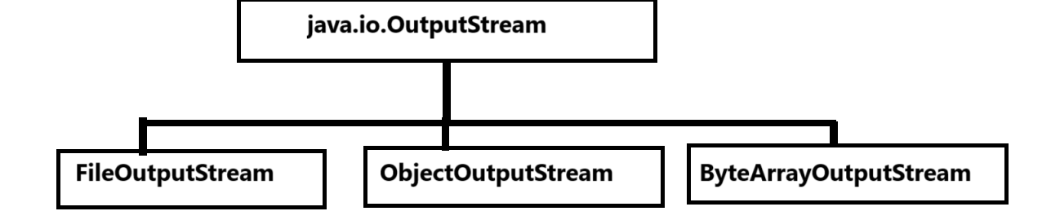

Now we want to discuss about OutputStream class
_____________________________________________________________________________________
Methods of OutputStream class

a) void write(byte): this method can write single byte at time in file
b) void write(byte[]): this method can write byte array data in file.
c) void write(byte[],int offset,int length): this method can write specified length or specified size of data in file.
d) void close(): this method can close the file.
e) void flush(): this method can flush the temporary buffer of file.

Now we want to discuss about the FileOutputStream class
____________________________________________________________________________________
FileOutputStream(String path): this constructor help us to accept the file path using string format and by default use the write mode.

FileOutputStream(String path,boolean mode): this constructor help us to accept the file path using string and decide file use append mode or not so if we pass second parameter as true then file can use append mode otherwise can use write mode.

FileOutputStream(File path): this constructor can accept file path using file class reference format.

FileOutputStream(File path,boolean mode): this constructor can accept file path using file class reference and decide file can use append mode or not if we pass true parameter then file can use append mode otherwise not.

Example: we want to input string from keyboard and write in file using byte format.
import java.io.*;
import java.util.*;
public class StreamApp
{
public static void main(String x[])throws Exception
{
FileOutputStream fout= new FileOutputStream("D:\\feb2024\\stream.txt");
Scanner xyz = new Scanner(System.in);
System.out.println("Enter data in file");
String data=xyz.nextLine();
byte b[]=data.getBytes();
fout.write(b);
fout.close();
System.out.println("Data Save Successfully.............");
}
}

InputStream class: InputStream class helps us to read data from file using byte format and this is the abstract class and it contain some abstract methods which help us to read data from file using byte format

Methods of InputStream
_____________________________________________________________________________________
int read(): this method can read single single byte data from file and return -1 when file is end.
int read(byte[]): this method can read complete byte array data from file and return its length and if file has no data then return -1.
int read(byte[],int offset,int length): this method can read specified length or size of data from file and return its length otherwise return -1.
void close(): this method can close the file.

Hierarchy of InputStream classes
______________________________________________________________________________
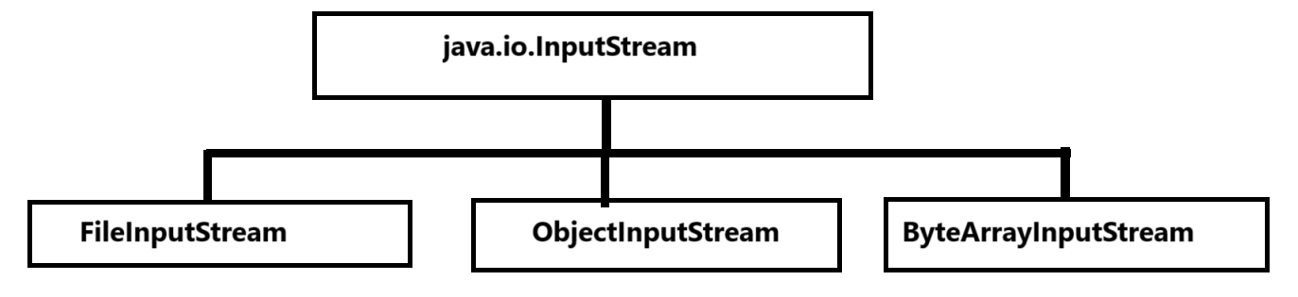

FileInputStream class

Constructor of FileInputStream class
_________________________________________________________________________
FileInputStream(String path): this constructor help us to accept the file path using string format.
FileInputStream(File path): this constructor help us to accept the file class reference using file class reference.

Example: we want to read stream.txt file which is preset in D:\\feb2024 folder
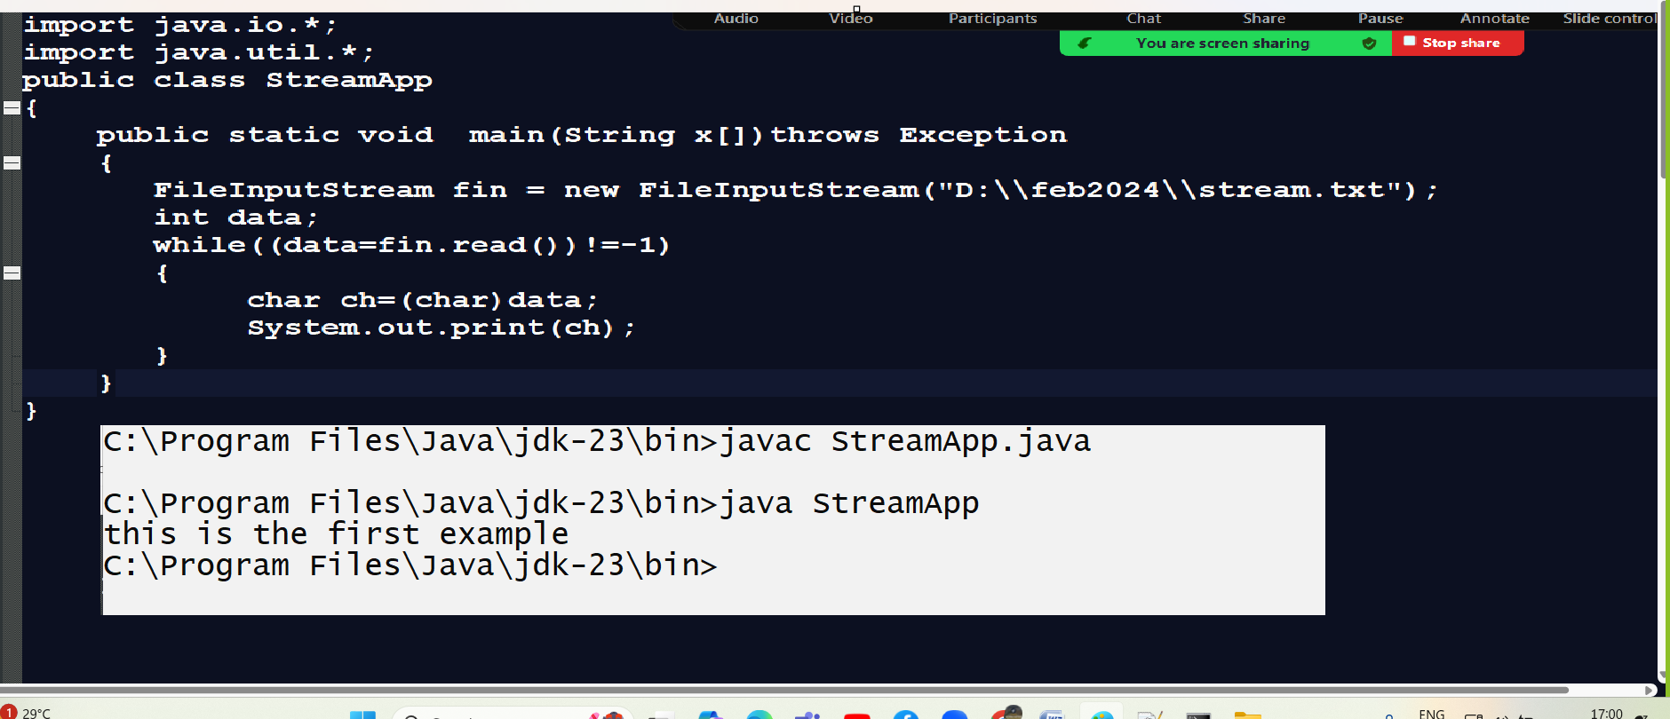

Example: WAP for create image copy paste application.
import java.util.*;
import java.io.*;
public class ImgCopyPasteApp
{
public static void main(String x[])throws Exception
{
FileInputStream fr = new FileInputStream("D:\\feb2024\\er.jpg");
FileOutputStream fw = new FileOutputStream("D:\\oct2024\\er.jpg");
int data;
while((data=fr.read())!=-1)
{
fw.write(data);

}
fw.close();
fr.close();
System.out.println("File Save Successfully............");
}
}

Serialization and Deserialization using JAVA
_____________________________________________________________________________________

Q. What is Serialization?
_____________________________________________________________________________________
Serialization is process for storing object in file or send in network with inbuilt encryption technique provided by java and it is achieve by using ObjectOutputStream class and Serializable interface.

Steps to work with Serialization using JAVA
_____________________________________________________________________________________
1. Add java.io package in application
import java.io.*;
2. Create POJO class and implements Serializable interface in it.
Note: Serializable is marker interface in java

Q. what is marker interface?
Marker interface means interface not present field or methods, and which is responsible for tag object and provide additional information about object to JVM called as marker interface
Example of Marker interface Cloneable, Serializable, Remote etc

import java.io.*;
class Employee implements Serializable
{
private int id;
private String name;
private int sal;

public void setId(int id)
{ this.id=id;
}
public int getId(){
return id;
}
public void setName(String name)
{ this.name=name;
}
public String getName(){
return name;
}
public void setSal(int sal)
{ this.sal=sal;
}
public int getSal(){
return sal;
}
}
3. Create Object of ObjectOutputStream class
ObjectOutputStream help us to write data in file and we have constructor of ObjectOutputStream
Syntax:
ObjectOutputStream ref = new ObjectOutputStream(OutputStream): we can pass here reference of OutputStream

Example with source code.
import java.io.*;
class Employee implements Serializable
{
private int id;
private String name;
private int sal;

public void setId(int id)
{ this.id=id;
}
public int getId(){
return id;
}
public void setName(String name)
{ this.name=name;
}
public String getName(){
return name;
}
public void setSal(int sal)
{ this.sal=sal;
}
public int getSal(){
return sal;
}
}
public class SApp
{
public static void main(String x[])
{
FileOutputStream fout=new FileOutputStream("D:\\feb2024\\demoemp.txt");
ObjectOutputStream oout= new ObjectOutputStream(fout);

}
}
4. Create object of POJO class and store in file using writeObject() method of ObjectOutputStream class
import java.io.*;
class Employee implements Serializable
{
private int id;
private String name;
private int sal;

public void setId(int id)
{ this.id=id;
}
public int getId(){
return id;
}
public void setName(String name)
{ this.name=name;
}
public String getName(){
return name;
}
public void setSal(int sal)
{ this.sal=sal;
}
public int getSal(){
return sal;
}
}
public class SApp
{
public static void main(String x[])throws Exception
{
FileOutputStream fout=new FileOutputStream("D:\\feb2024\\demoemp.txt");
ObjectOutputStream oout= new ObjectOutputStream(fout);
Employee emp1 = new Employee();
emp1.setId(1);
emp1.setName("ABC");
emp1.setSal(10000);
oout.writeObject(emp1);
oout.close();
System.out.println("Success...............");
}
}

Deserialization: Deserialization is process to read object data from file called as deserialization
If we want to read object data from file we have FileInputStream class and its readObject() method and if we not contain data return null otherwise not.

import java.io.*;
class Employee implements Serializable
{
private int id;
private String name;
private int sal;

public void setId(int id)
{ this.id=id;
}
public int getId(){
return id;
}
public void setName(String name)
{ this.name=name;
}
public String getName(){
return name;
}
public void setSal(int sal)
{ this.sal=sal;
}
public int getSal(){
return sal;
}
}
public class SApp
{
public static void main(String x[])throws Exception
{
FileInputStream fin=new FileInputStream("D:\\feb2024\\demoemp.txt");
ObjectInputStream oin= new ObjectInputStream(fin);

Employee e=(Employee)oin.readObject();
System.out.println(e.getId()+"\t"+e.getName()+"\t"+e.getSal());
System.out.println("Success...............");
}
}

